Clark County Fire Department (CCFD) Permit Application Portal: https://www.clarkcountynv.gov/government/departments/building___fire_prevention/citizen_access_portal.php
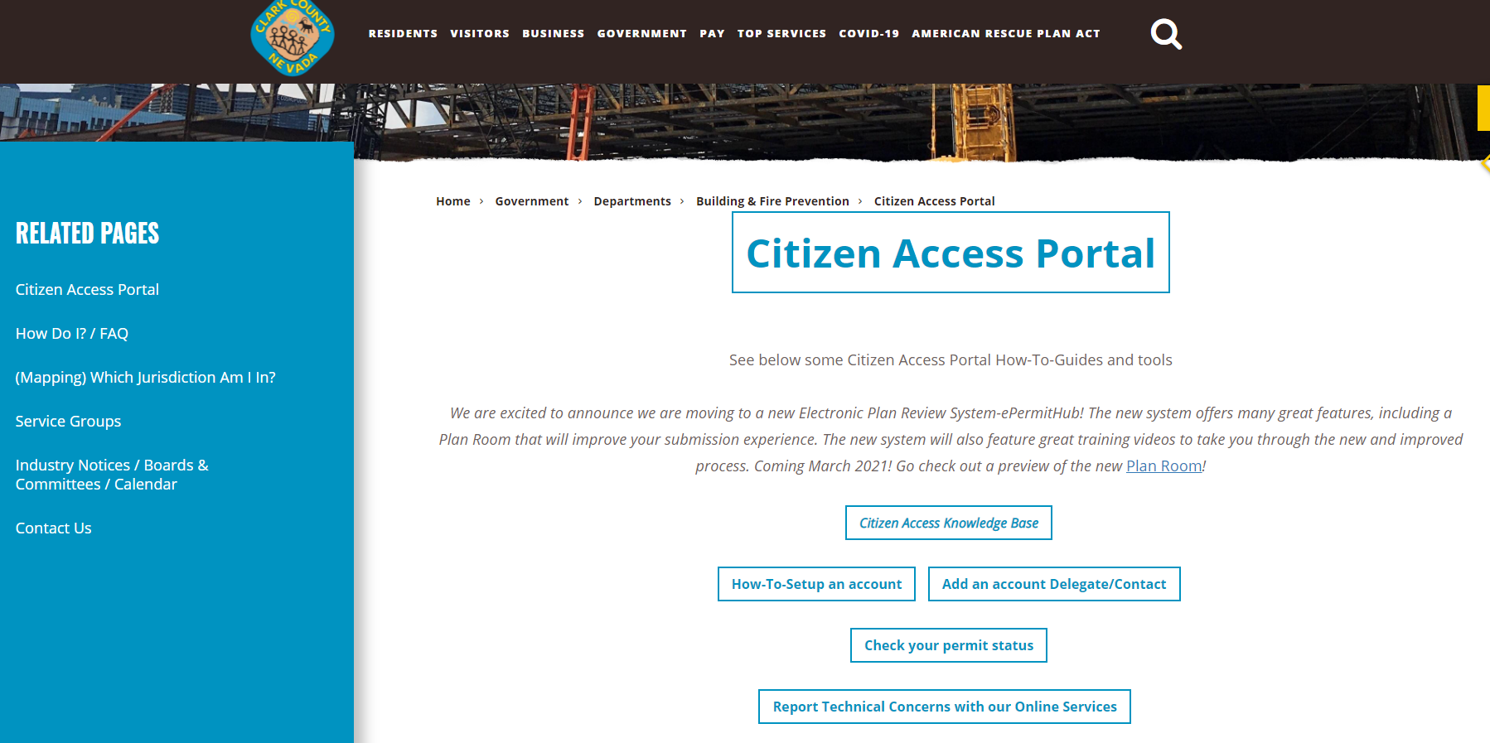

Create a portal account:
https://citizenaccess.clarkcountynv.gov/CitizenAccess/Login.aspx
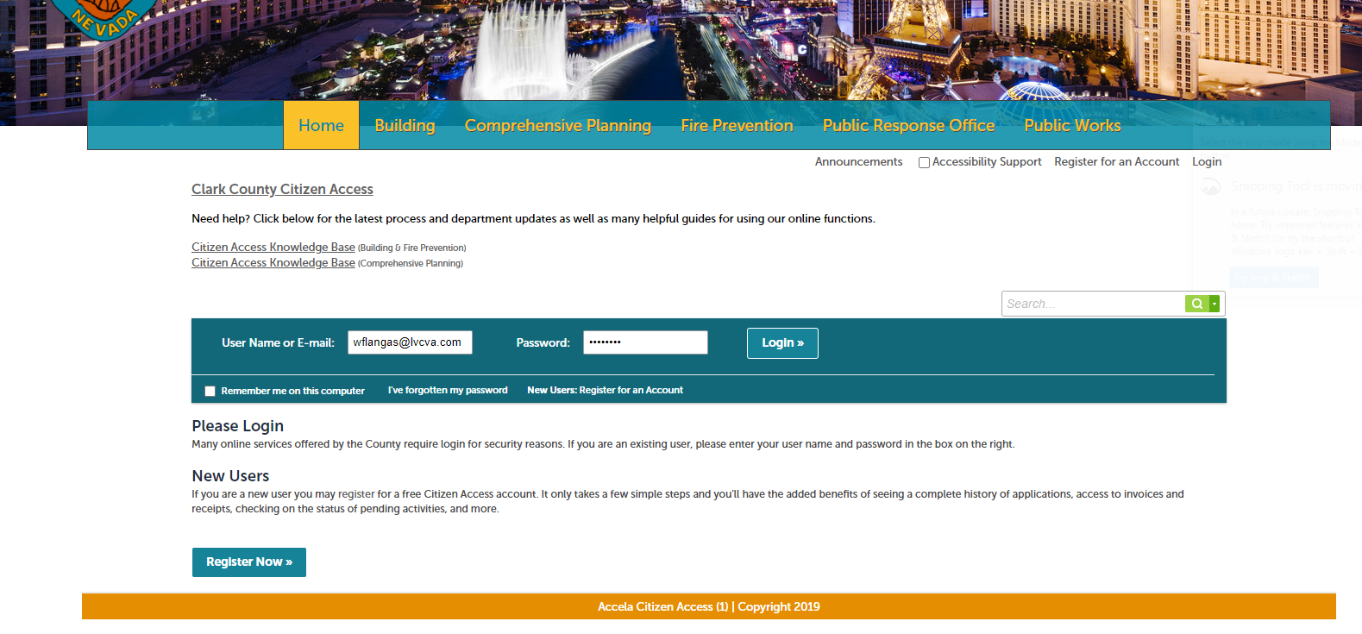

Fire Prevention Tab – Apply for permit
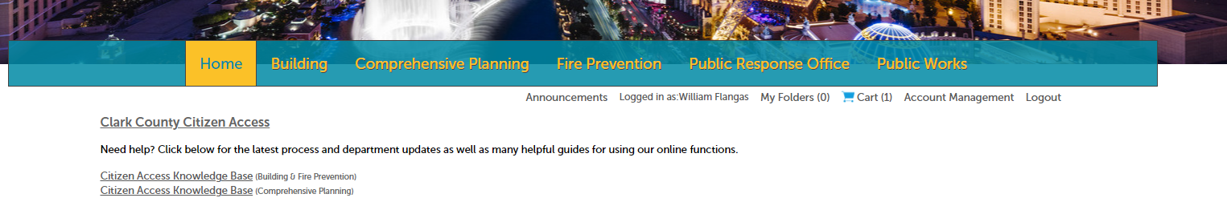

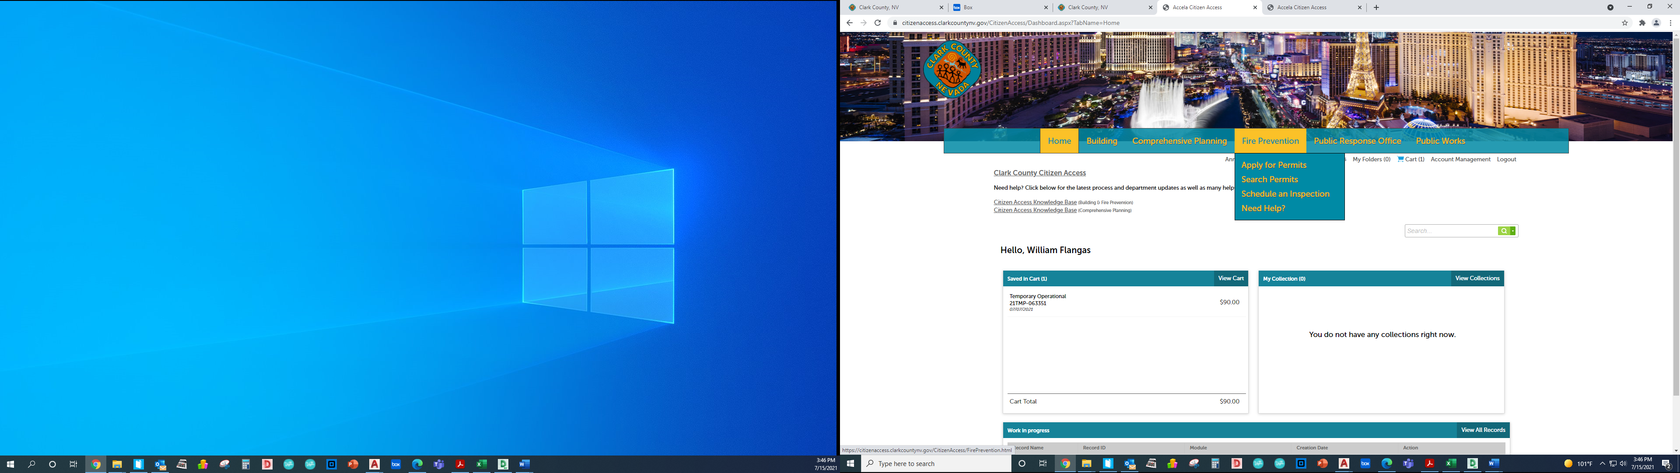

Accept terms and continue application:
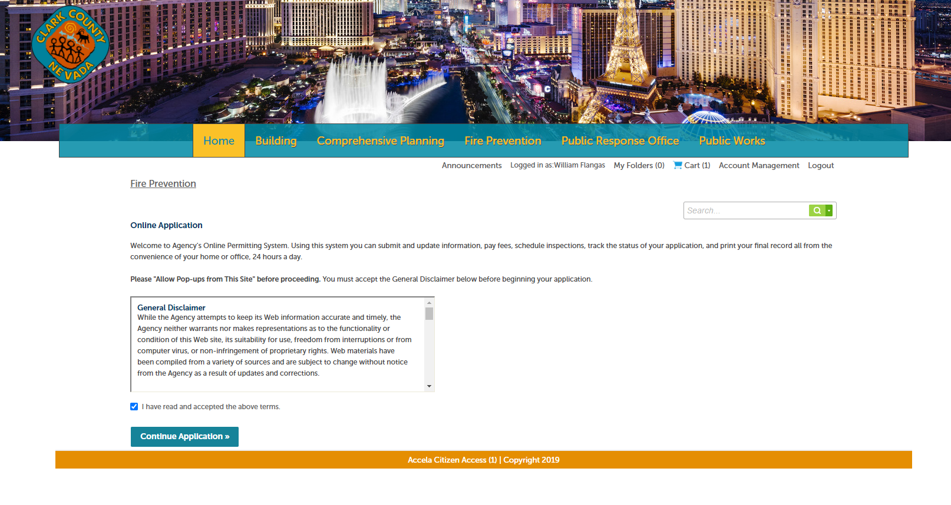

Choose Temporary Event Permits (Plan Upload Required) and continue application:
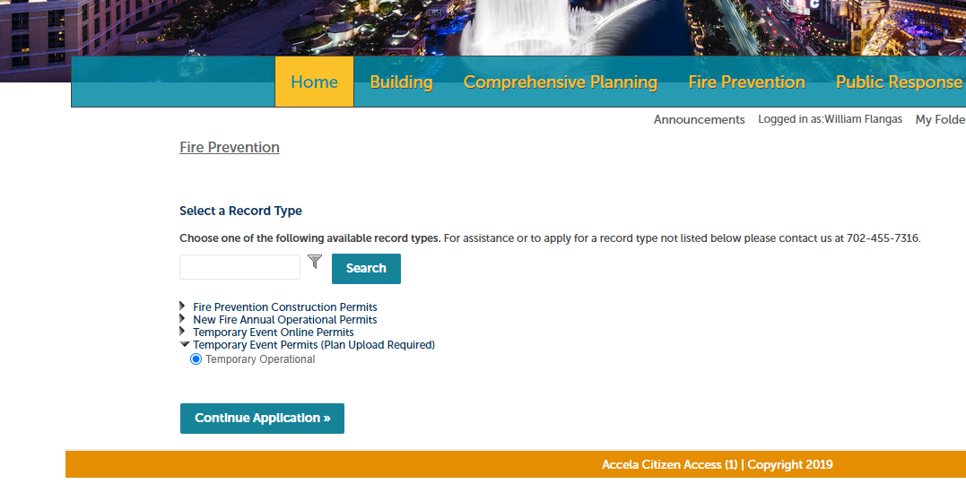
Fill in appropriate boxes:
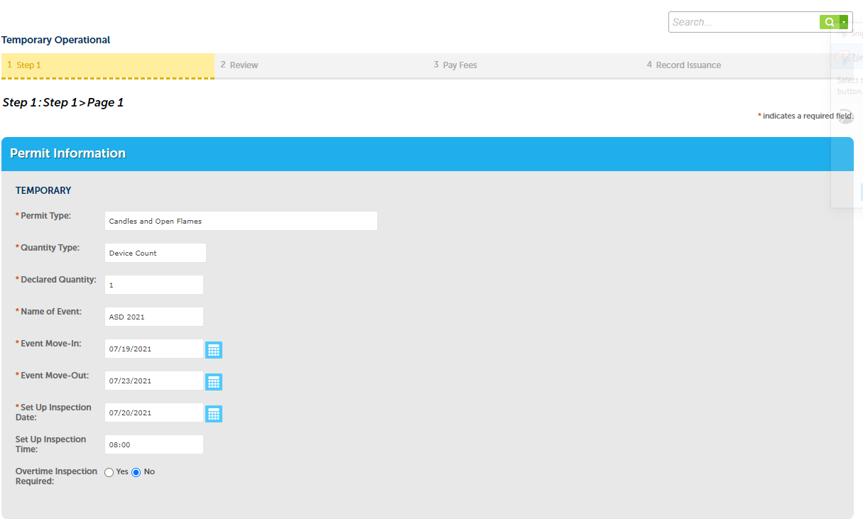
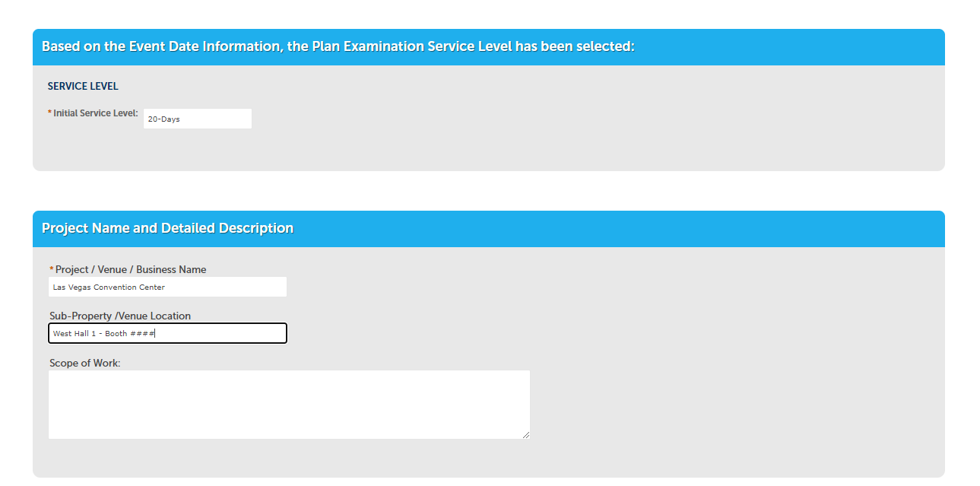
Fill in LVCC Address:
3150 Paradise Rd (pick first parcel number)
300 Convention Center Dr (parcel number will fill in automatically)
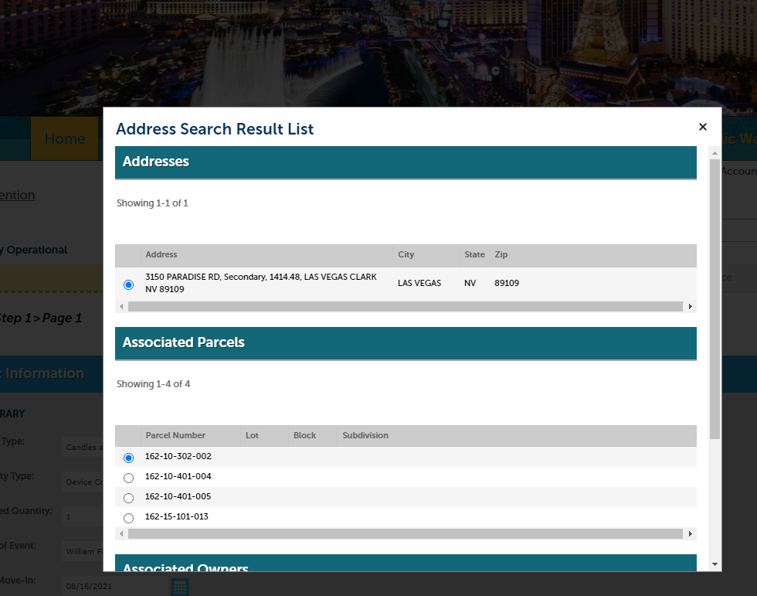
Fill in applicant information:
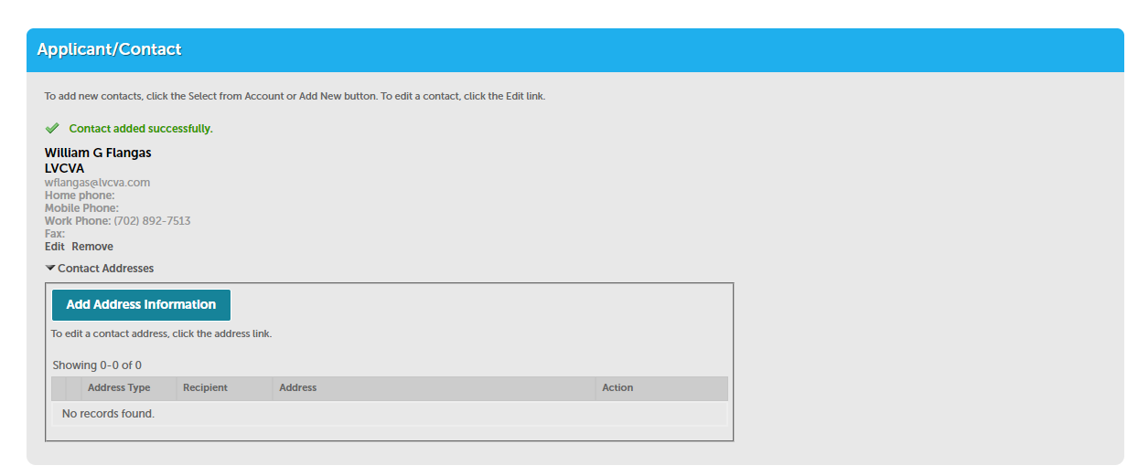
Fill in submitting company:
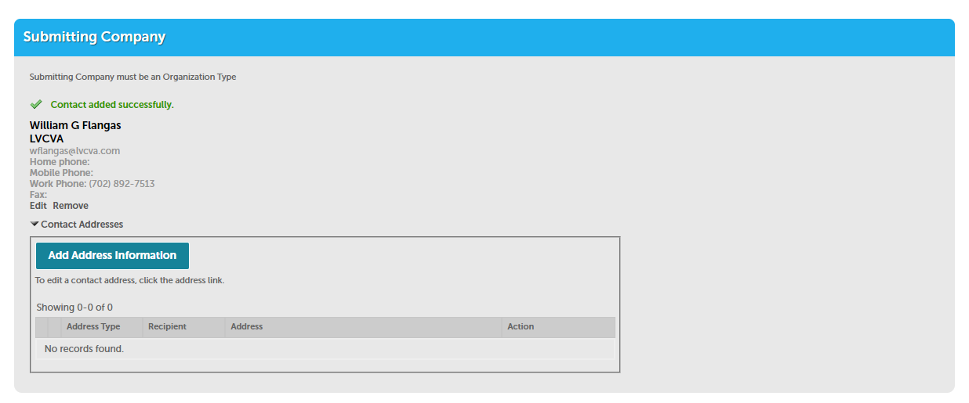
Fill in on-site contact information with cell phone numbers: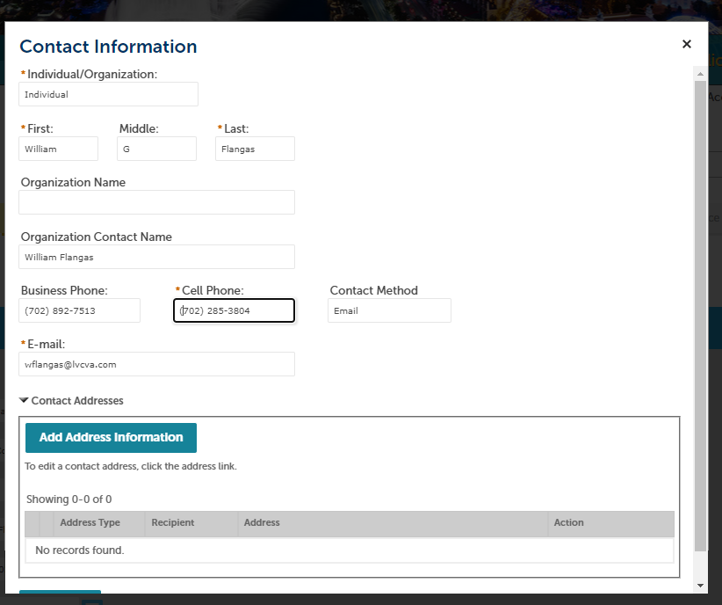
Acknowledge that you will upload plans, documentation and attachments:
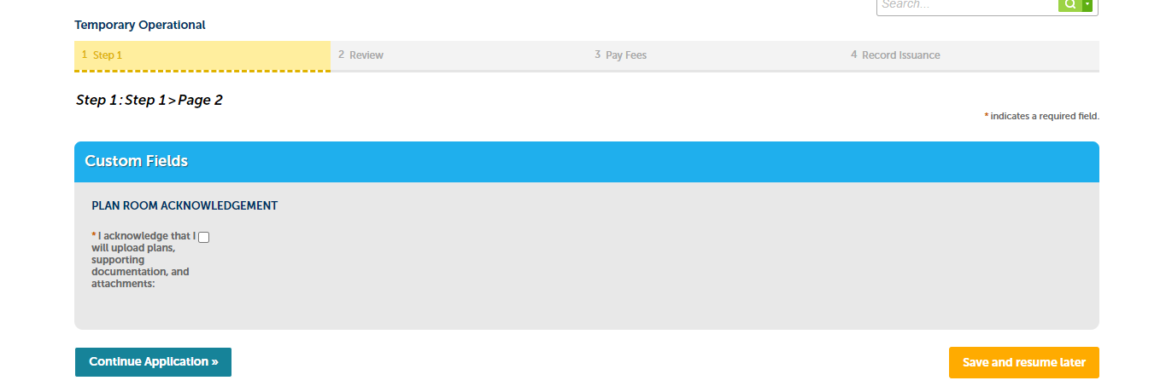
Check out and pay fees:
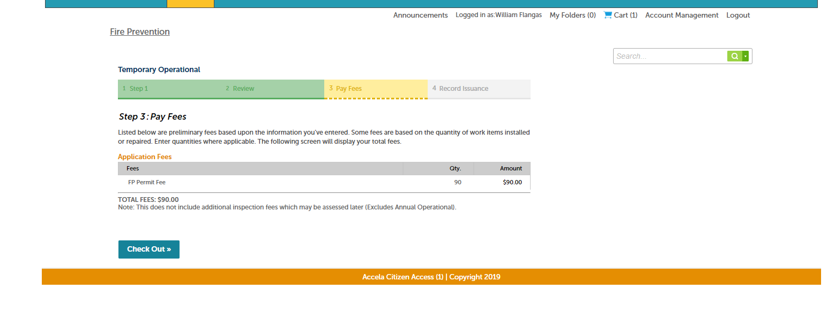
**This is as far as we can go prior to completing and paying for the transaction.
After this page, there are (3) upload areas:
- Plans file – Pictures of the lighters and floor plan with location
- Application file
  - The pdf of the application they are asking to be uploaded (redundant I know)
- Correspondence file – any explanations you have and/or SDS sheets
Link: Permit Application
Questions:
- T: 1 (702) 455-3000
- E: permits@ClarkCountyNV.gov

