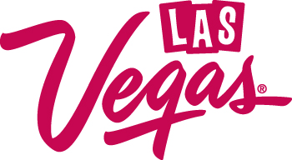

The Las Vegas Convention and Visitors Authority and Clark County Fire Code prohibit flammable liquid, gasses or solids in the Las Vegas Convention Center.

Reasonable accommodations can be made for items that are for demonstration purposes.

LIGHTERS
Storage of lighters in a booth is prohibited.

For display: Disposable lighters on display is allowed.

For demonstration: Requires an open flame permit from Clark County Department of Building and Fire Prevention. Click here for additional information.

For giveaways: Exhibitors can keep a one-day supply of lighters in the booth, if giving away lighters to attendees.

TORCHES
For display: Butane/propane torches for display must be empty of fuel.

For demonstration: requires an open flame permit from Clark County Department of Building and Fire Prevention. Click here for additional information.

REFILL CONTAINERS/CANISTERS
Fuel refill containers on display must be empty. This includes all butane or propane refill tanks and containers of lighter fluid.

All other flammables on display (such aerosol spray cans) must be empty display models.

Applications for open flame permits can be submitted online at: https://www.clarkcountynv.gov/government/departments/building___fire_prevention/index.php or by email: permits@ClarkCountyNV.gov

To create a new account go here: https://www.clarkcountynv.gov/government/departments/building___fire_prevention/citizen_access_portal.php
Select the box labeled Candles and Open Flames and fill out the required information prior to submitting. If you need assistance, please contact the LVCVA Safety and Fire Prevention Office for assistance, (702) 892-7413.

