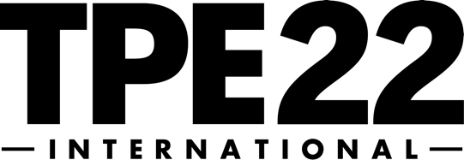
January 26–28, 2021
TPE22 Exhibitor Press Release Template
FOR ADDITIONAL INFORMATION FOR IMMEDIATE RELEASE
Contact: [YOUR NAME] [RELEASE DATE]
Phone: [YOUR PHONE]
Email: [YOUR CONTACT EMAIL]
Twitter: [HASHTAG]

[YOUR COMPANY] TO EXHIBIT IN LAS VEGAS AT TPE22

[COMPANY] to exhibit at the largest business-to-business tobacco trade show highlighting new products for the tobacco, vapor, and alternative industries

[YOUR CITY] — Recognizing the advantage of exhibiting with North America’s most comprehensive showcase of tobacco, vapor, alternative, and general merchandise products on the market, [COMPANY] has chosen to exhibit and highlight its newest [PRODUCTS/EQUIPMENT/SERVICES] at TPE22 in January 2022 at the Las Vegas Convention Center in Las Vegas, Nevada.
TPE runs three consecutive days, with the show floor open to each day: Wednesday, January 26 (12:00PM–5:00PM); Thursday, January 27 (10:30AM–5:00PM); Friday, January 28 (10:30AM–4:00PM), 2021.
“The show floor features conferences, educational forums, new products, networking, and exhibition opportunities that make TPE the ideal venue for our [PRODUCTS/EQUIPMENT/SERVICES LAUNCH OR LIVE DEMONSTRATIONS],” said [YOUR COMPANY SPOKESPERSON].

[YOUR COMPANY DETAILS HERE]

In addition to anticipated show floor introductions of new products and related industry services, TPE has created IGNITE from TMG—the new online networking and event platform where tobacco, vapor and alternative buyers and sellers can do business 24/7. As a complement to the annual, in-person TPE events, IGNITE will offer year-round industry education, manufacturer and product showcases, virtual events, matchmaking and more!

Returning this year, TPE also welcomes National Association of Tobacco Outlets (NATO), who will present educational seminars at TPE 2021. Tobacco Plus Expo is the only 2021 B2B trade show in North America to blend critical education, new products, themed show floor sampling lounges, plus outstanding networking opportunities between exhibitors, retailers, industry leaders, and buyers. Registration and reservations may be completed at www.tobaccoplusexpo.com.

About [YOUR COMPANY: Enter your copy and contact information here.]

About Tobacco Plus Expo
Under the banner of Tobacco Media Group (TMG) owned by Kretek International, Tobacco Plus Expo (TPE) is the largest business-to-business tobacco trade show highlighting the full-spectrum of tobacco, vapor, alternative, and general merchandise products available within the ever-evolving market. TPE 2021 promises to deliver the industry’s most compelling content and will be held May12–May14, 2021 at the Las Vegas Convention Center. To learn more about TPE, please visit the website: www.tobaccoplusexpo.com.

