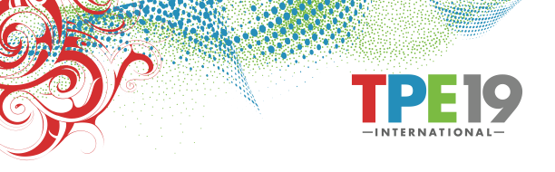
Exhibitor Highlights

TPE 2019 now offers contracted exhibitor’s free marketing of new products that will be displayed, demonstrated, and/or sampled in your booth on the TPE show floor. It is simple: complete this form and email it with images/logos to: antoinereid@tobaccobusiness.com

Company__________________________________________ Booth #____________________
Contact Person_____________________________________ Phone______________________
Email__________________________________ Company Website________________________
Twitter Account________________________________________________________________
Linked-in Account_______________________________________________________________
Facebook Account_______________________________________________________________
Instagram Account_______________________________________________________________
Image requirements: Images are requested in jpg, tiff, or png format. Images should be print-ready, high-resolution and 300 dpi.
Press Release: Please send us news about your company, products and brands for possible coverage in Tobacco Business Magazine and TPE’s quarterly newsletter.
Instagram/Social Media Promotion: Please send us a high-resolution logo of your company, preferably with a transparent background (png). For any product promotions via our social media channels, including a product tagline or one-sentence description along with your company’s social media handles and any special hashtags you would like us to use.

TPE will help market these products before TPE 2019, During TPE 2019 and after TPE 2019.
These products will be promoted using one or more communication channels at TPE discretion.
Promotional channels such as: social media, blogs, posts, articles, website, releases, photos, videos,
e-mail campaigns, brochures, signage, new product graphics and other media may be used.
Complete and email this completed form for quick promotions today! antoinereid@tobaccobusiness.com

